ISO 20022 Governance and Registration Process for API Resources

# Problem statement

Financial Institutions have traditionally faced their customers directly. In recent years, there has been a strong movement globally to opening up banking services to new entrants and technologies. The recent implementation of PSD2 in Europe and the introduction of new technologies such as web-based APIs for Payments, Securities and Cards, micro-services and new types of players has lead to a fragmentation of the market.

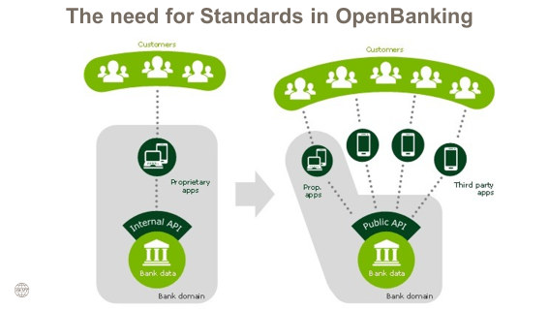

What used to be services only provided by FIs has now become an ecosystem where the FIs now only play a smaller part in.

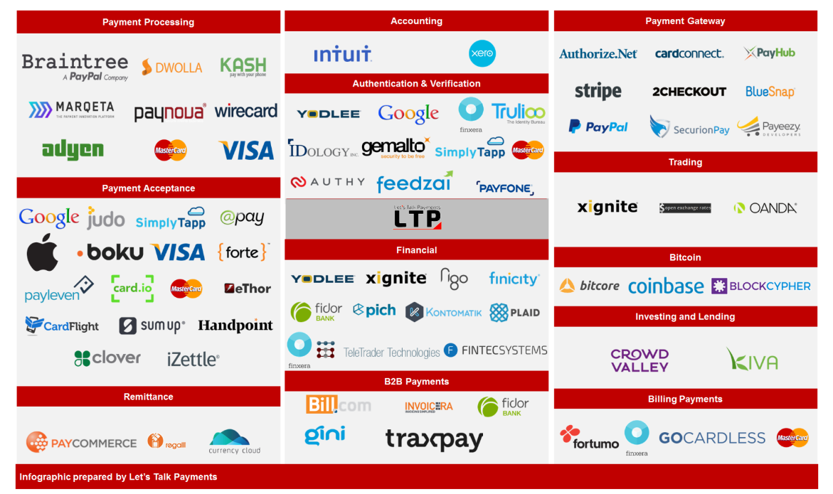

The lack of a common business standard and standardisation approach results in players having to support and implement various different implementations of the same services.

This uncoordinated, “Balkanized” standards development expands fraud risks, creates friction and further increases interoperability costs.

# Benefits of using ISO 20022

The reuse of the ISO 20022 business model in the context of resources ensures consistency of business data with ISO 20022 messages which guarantees straight-through-processing throughout the entire financial transaction life cycle.

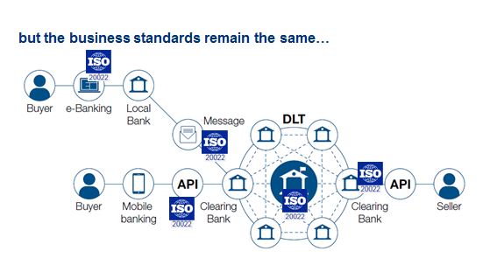

ISO 20022 to foster interoperability independently of the underlying technology

# Scope

API development happens in two steps:

1. Standardising the API Resources: API Resources represent data models that a service provider exposes to its clients via API methods. Standardised business elements are reused as much as possible in order to model the business content of the data model. Standardised Resources will ease the integration of the APIs for the API consumer with other standardised (API) services.
2. Standardising the APIs: This goes a step further than the resources standardisation. Here the API designer designs the methods, e.g., the API calls that manage the resources (read, change, create etc.). This part is not covered in this document, as API development is not part of the ISO 20022 methodology at this moment in time.

# Request for approval

This proposal requests the RMG to approve the use of ISO 20022 components to model ISO 20022 compliant API Resources and establish the associated standardized registration process thereby addressing the challenges captured in the previous section.

The rest of this document proposes some considerations to an implementation of the process and the governance to develop, register and maintain ISO 20022 compliant API Resources.

## Governance and registration process for development of new ISO 20022 compliant resources

An organisation wishing to develop ISO 20022 compliant resources can register their resources with the ISO 20022 RA according to the process described hereafter. The registration process may either relate to the development of new resources, as well as to their maintenance. Registration can be done at any time.

The registration process of ISO 20022 compliant resources aims at addressing requirements for an agile API development environment. Developers can design and maintain their resources and APIs at their own pace, based on official ISO 20022 resources. In this way, interoperability is guaranteed, whilst the management of APIs is kept extremely flexible.

The registration process includes four phases:

1. The request for registration
2. The development
3. The evaluation
4. The publication

### Request for registration

An organisation (‘submitting organisation’) wishing to develop a new ISO 20022 compliant resource must submit a simple request to the ISO 20022 RA at [iso20022ra@iso20022.org](mailto:iso20022ra@iso20022.org) where it is checked for completeness, logged on the ISO 20022 website and confirmed to the submitting organisation within the next three business days. The request should explain the purpose of the development, the business transactions (business area) involved, eg, payments initiation, as well as the timing.

The ISO 20022 RA will forward the request to the ISO 20022 API Evaluation team[1] for comments. If the ISO 20022 API Evaluation Team has no comments within the next five to ten business days, the request is approved.

When the request is approved, the RA will – in case of resource creation - provide to the submitting organisation the ISO 20022 Lite Editor that allows for easy access to the latest version of the ISO 20022 Repository. This editor will be provided free of charge by the ISO 20022 RA after the Licence Terms document has been duly completed and returned to the RA by the submitting organisation.

APIs themselves will not be registered by the ISO 20022 RA. (cf. Scope)

### Development

The RA has limited resources which are not available for development work, but provides the submitting organisation with a clear description of the required deliverables, the materials necessary to set up the required modelling environment and a 'compliance checklist' of rules to observe to ensure ISO 20022 compliant resources.

The submitting organisation wishing to register resources selects through the use of the Lite Editor the relevant ISO 20022 message components in the ISO 20022 Repository to design the resources. If the desired message components do not exist, new ones can be proposed. The ISO 20022 RA will provide ISO 20022 API modelling guidelines that need to be followed for the development of the resources so that they are developed in a standardised and consistent manner.

The submitting organisation is expected to develop the ISO 20022 compliant resources within the timeframe indicated in its request for registration. If during the development, the submitting organisation determines that the ISO 20022 compliant resources will not be ready for delivery to the RA at the date specified in the business justification, it will promptly inform the RA about the new submission date.

### Evaluation

Once the resource is stable, the submitting organisation submits the ISO 20022 compliant resource model to the ISO 20022 RA who checks the compatibility according to the ISO 20022 modelling guidelines within a reasonable timeframe[2] - on a first in first out basis.

Upon detection of non-compliance the ISO 20022 RA shall return the resource to the submitting organisation with the reasons for the non-compliance. The submitting organisation is required to correct the deficiencies and resubmit.

When the submission is compliant, new or updated resource components may be registered by the RA before evaluation and appear as ‘provisionally registered’ in the Dictionary.

The RA generates the evaluation documentation and sends it to the members of the ISO 20022 API Evaluation Team.

The documentation generated by the RA is provided by e-mail, and/or uploaded in an ISO 20022 Workspace folder that is available to the members of the ISO 20022 API Evaluation Team. The documentation contains the following:

* A preliminary Resource Definition Report (RDR) with the full description of the new Resources. The RDR is made of two parts: the first part is written by the submitting organisation to describe the business transactions (state diagram, interaction diagram…) for which the proposed resources will be used, the second part is a detailed description of the contents of each resource definition that is generated by the RA directly from the model.
* JSON Schemas describing the resources. JSON Schemas are generated according to the JSON Transformation Rules published in the TS 23029 (expected to be available Q1 2020).
* If requested by the submitting organisation, the RA will also provide OAS 3.x API contract(s) that specify the generic APIs based on the submitted resources. These generic API contracts can then be used by the submitter to further define/refine their API contracts.

In addition to the evaluation documentation provided by the RA, the submitting organisation is expected to give an introductory presentation to the API Evaluation Team members and may propose additional documentation to further facilitate the evaluation of the submission.

As a first step, the API Evaluation Team shall verify that the submission is within the scope expressed in the corresponding request to the RA. The API Evaluation Team evaluates the candidate ISO 20022 compliant resources from a business standpoint before they are officially accepted and published as ISO 20022 compliant resources. A recommendation shall be given by the API Evaluation Team as quickly as possible and shall take no longer than one calendar month, unless otherwise agreed with the RA (e.g., when the submission covers a large number of items).

### Publication

After the evaluation phase is completed, and the ISO 20022 compliant resources are approved by the ISO 20022 API Evaluation Team, the ISO 20022 RA will publish the ISO 20022 compliant resources on [www.iso20022.org](http://www.iso20022.org).

The RA will publish a (set of) Resources as JSON Schemas. JSON Schemas are generated according to the JSON Transformation Rules published in the *TS 23029 (expected to be available early 2020).*

### Withdrawal

At any time during the registration or maintenance process and until the resources are approved by the API Evaluation Team for publication, the submitting organisation may decide to withdraw or suspend its submission, simply by informing the RA and providing the reason for such decision.

## Governance and registration process for the maintenance of existing ISO 20022 compliant resources

The maintenance process includes four phases:

1. The request for maintenance
2. The development of the maintained resource
3. The evaluation
4. The publication

### Request for maintenance

Any organisation can submit a change request (template to be developed) for an existing ISO 20022 compliant resource to the ISO 20022 RA at [iso20022ra@iso20022.org](mailto:iso20022ra@iso20022.org) where it is checked for completeness, logged on the ISO 20022 website and confirmed to the organisation within the next three business days. The request should explain the purpose of the maintenance, the details of the requested maintenance, as well as the timing.

The ISO 20022 RA will forward the change request to the submitting organisation of the resource, as well as to the ISO 20022 API Evaluation team for review and approval.

### Development

When the ISO 20022 API Evaluation Team approves the change request, the submitting organisation can maintain its resource through the use of the Lite Editor. If the desired message components do not exist, new ones can be proposed. The ISO 20022 RA will provide ISO 20022 API modelling guidelines that need to be followed for the maintenance of the resources so that they are maintained in a standardised and consistent manner.

The submitting organisation may choose to defer the implementation of the change request until a later date to be agreed with the ISO 20022 API Evaluation Team.

### Evaluation

Once the resource is updated, the submitting organisation submits the updated ISO 20022 compliant resource model to the ISO 20022 RA who checks the compatibility according to the ISO 20022 modelling guidelines within a reasonable timeframe[3] - on a first in first out basis.

Upon detection of non-compliance the ISO 20022 RA may return to the submitting organisation with the reasons for the non-compliance. The submitting organisation is then supposed to correct and resubmit.

When the submission is compliant, new or updated resource components may be registered by the RA before evaluation and appear as ‘provisionally registered’ in the Dictionary.

The RA generates the evaluation documentation and sends it to the members of the API Evaluation Team.

The documentation generated by the RA is provided by e-mail, and/or uploaded in an ISO 20022 Workspace folder that is available to the members of the API Evaluation Team. The documentation contains the following:

* An updated Resource Definition Report (RDR) with the full description of the maintained resources. The RDR is made of two parts: the first part is updated by the submitting organisation to describe the business transactions (state diagram, interaction diagram…) for which the proposed resources will be used, the second part is a detailed description of the contents of each resource definition that is generated by the RA directly from the model.
* Updated JSON Schemas describing the resources.

### Publication

After the evaluation phase is completed, and the maintained ISO 20022 compliant resources are approved by the ISO 20022 API Evaluation Team, the ISO 20022 RA will publish the updated ISO 20022 compliant resources on [www.iso20022.org](http://www.iso20022.org).

The RA will publish a (set of) Resources as JSON Schemas.

1. Organisation and governance to the discretion of the RMG

  
2. The RA has limited resources to perform RA services such as the compliance review of the submissions, the provisional and official registration, the preparation of the documentation, the publication of the Repository, the maintenance of the ISO 20022 website, the participation in the various ISO 20022 related groups and subgroups, the answer to various internal and external queries, the training of RMG and SEG members, etc.
3. The RA has limited resources to perform RA services such as the compliance review of the submissions, the provisional and official registration, the preparation of the documentation, the publication of the Repository, the maintenance of the ISO 20022 website, the participation in the various ISO 20022 related groups and subgroups, the answer to various internal and external queries, the training of RMG and SEG members, etc.